**Exercise 5 REACTJS-HOL**

**OBJECTIVES**

1. **Understanding the need for styling react component**

Styling improves the **visual appearance** and **usability** of React components. It helps in maintaining a **consistent UI design** across the application. Styles make components more **interactive** and user-friendly. Well-structured styling ensures **separation of concerns** between logic and presentation. It allows developers to **customize components** based on props, themes, or screen size.

1. **Working with CSS Module and inline styles**

**CSS Modules** scope styles locally to components, preventing style conflicts. You can import a .module.css file and apply styles using className={styles.className}. **Inline styles** allow dynamic styling using JavaScript objects. Use inline styles for **conditional rendering** (e.g., change color based on status). Combining both approaches gives flexibility in managing styles efficiently.

**HANDS ON PRACTICE**

**CODE STRUCTURE:**

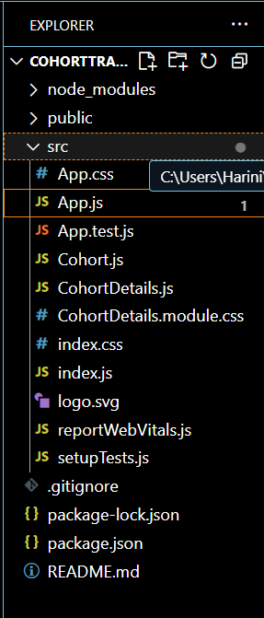

1. **Create a new CSS Module in a file called “CohortDetails.module.css”**

**CohortDetails.module.css**

.box{

  width: 300px;

  display: inline-block;

  margin: 10px;

  padding: 20px 10px 20px 10px;

  border: 1px solid black;

  border-radius: 10px;

}

.dt{

  font-weight: 500;

}

1. **Open the cohort details component and import the CSS Module**

**CorhortDetails.js**

// CohortDetails.js

import React from "react";

import styles from "./CohortDetails.module.css"; // import the module

function CohortDetails(props) {

  const { cohort } = props;

  const headingStyle = {

    color: cohort.currentStatus === "Ongoing" ? "green" : "blue",

  };

  return (

    <div className={styles.box}>

      <h3 style={headingStyle}>

        {cohort.cohortCode} - <span>{cohort.technology}</span>

      </h3>

      <dl>

        <dt>Started On</dt>

        <dd>{cohort.startDate}</dd>

        <dt>Current Status</dt>

        <dd>{cohort.currentStatus}</dd>

        <dt>Coach</dt>

        <dd>{cohort.coachName}</dd>

        <dt>Trainer</dt>

        <dd>{cohort.trainerName}</dd>

      </dl>

    </div>

  );

}

export default CohortDetails;

**Cohert.js**

class Cohort {

    constructor(cohortCode,

        startDate,

        technology,

        trainerName,

        coachName,

        currentStatus) {

        this.cohortCode = cohortCode;

        this.coachName = coachName;

        this.trainerName = trainerName;

        this.technology = technology;

        this.startDate = startDate;

        this.currentStatus = currentStatus;

    }

}

const CohortsData =[

    new Cohort('INTADMDF10','22-Feb-2022', '.NET FSD', 'Jojo Jose','Aathma', 'Scheduled'),

    new Cohort('ADM21JF014','10-Sep-2021', 'Java FSD', 'Elisa Smith','Apoorv', 'Ongoing'),

    new Cohort('CDBJF21025','24-Dec-2021', 'Java FSD', 'John Doe','Aathma', 'Ongoing'),

    new Cohort('INTADMJF12','22-Feb-2022', 'Java FSD', 'To Be Assigned','Ibrahim', 'Scheduled'),

    new Cohort('CDE22JF011','24-Dec-2021', 'Java FSD', 'Emma Swan','Apoorv', 'Ongoing'),

    new Cohort('INTADMDF09','22-Feb-2022', 'Dataware Housing', 'Babjee Rao','Aathma', 'Scheduled'),

    new Cohort('ADM22DF001','10-Sep-2021', '.NET FSD', 'Marie Curie','Ibrahim', 'Ongoing'),

];

export {Cohort, CohortsData};

1. **Output**

